Hive View and Hive Index
https://data-flair.training/blogs/hive-view-hive-index/

What is Hive view?
Basically, Apache Hive View is similar to Hive tables, that are generated on the basis of requirements.
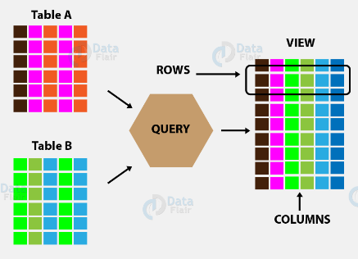

- As a Hive view, we can save any result set data.
- Well, we can say its usage is as same as the use of views in SQL.
- Although, we can perform all type of DML operations on Hive views.
In other words, Apache Hive View is a searchable object in a database which we can define by the query. However, we can not store data in the view. Still, some refer to as a view as “virtual tables”. Hence, we can query a view like we can a table. Moreover, by using joins it is possible to combine data from or more table. Also, it contains a subset of information.
CREATE VIEW [IF NOT EXISTS] view_name [(column_name [COMMENT column_comment], …) ]
[COMMENT table_comment]
AS SELECT …
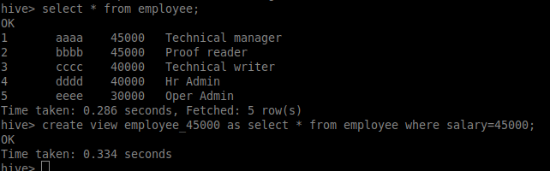

Create a new entry in metastore as TBL_TYPE=VIRTUAL_VIEW
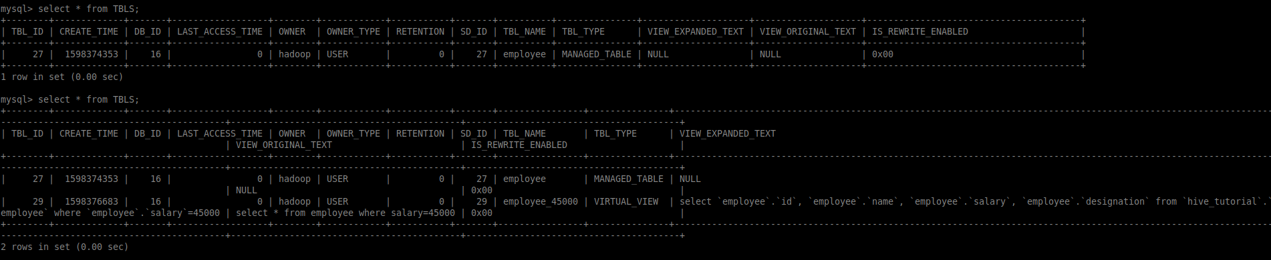

This is a logical view and no storage is associated with it. It will send map reduce queries each time it is called.

The view can be seen both nder table and views
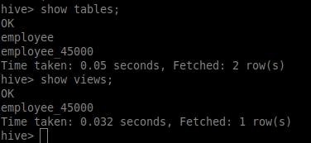

When the table associated with view is dropped, then view is not dropped.
Query on the view fails
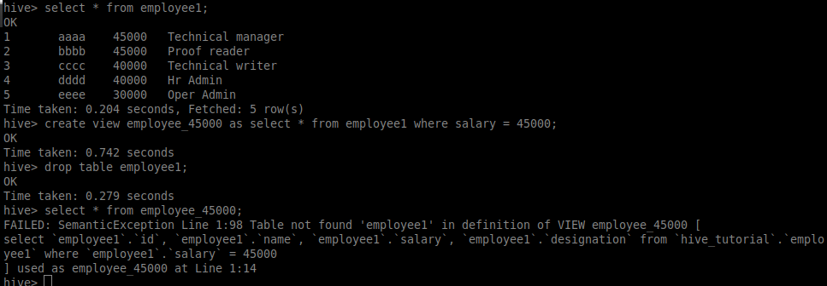

Drop a Hive View

DROP VIEW view_name
Cannot use drop table statement for view, need use drop view only.
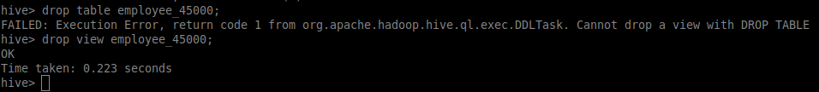

What is Apache Hive Index?
Indexing Is Removed since hive version 3.0

https://cwiki.apache.org/confluence/display/Hive/LanguageManual+Indexing

On defining indexing in Hive we can say these are pointers to particular column name of a table.
- However, the user has to manually define the Hive index
- Basically, we are creating the pointer to particular column name of the table, wherever we are creating Hive index.
- By using the Hive index value created on the column name, any Changes made to the column present in tables are stored.

CREATE INDEX index_name
ON TABLE base_table_name (col_name, ...)
AS 'index.handler.class.name'
[WITH DEFERRED REBUILD]
[IDXPROPERTIES (property_name=property_value, ...)]
[IN TABLE index_table_name]
[PARTITIONED BY (col_name, ...)]
[
[ ROW FORMAT ...] STORED AS ...
| STORED BY ...
]
[LOCATION hdfs_path]
[TBLPROPERTIES (...)]

Dropping an Index
The following syntax is used to drop an index:
DROP INDEX <index_name> ON <table_name>

